Tutorial 1

Module Name: Login Module - Functional Test Cases
Test Case ID: TC01
Tester Name: Vora Riya

Scenarios:
- Scenario ID: 1a
Scenario
Verify Login page is accessible
Test Steps
1. Open Google Chrome.
2. Enter the Practice Test Automation login page URL.
3. Wait for the page to load completely.
4. Observe the login page.
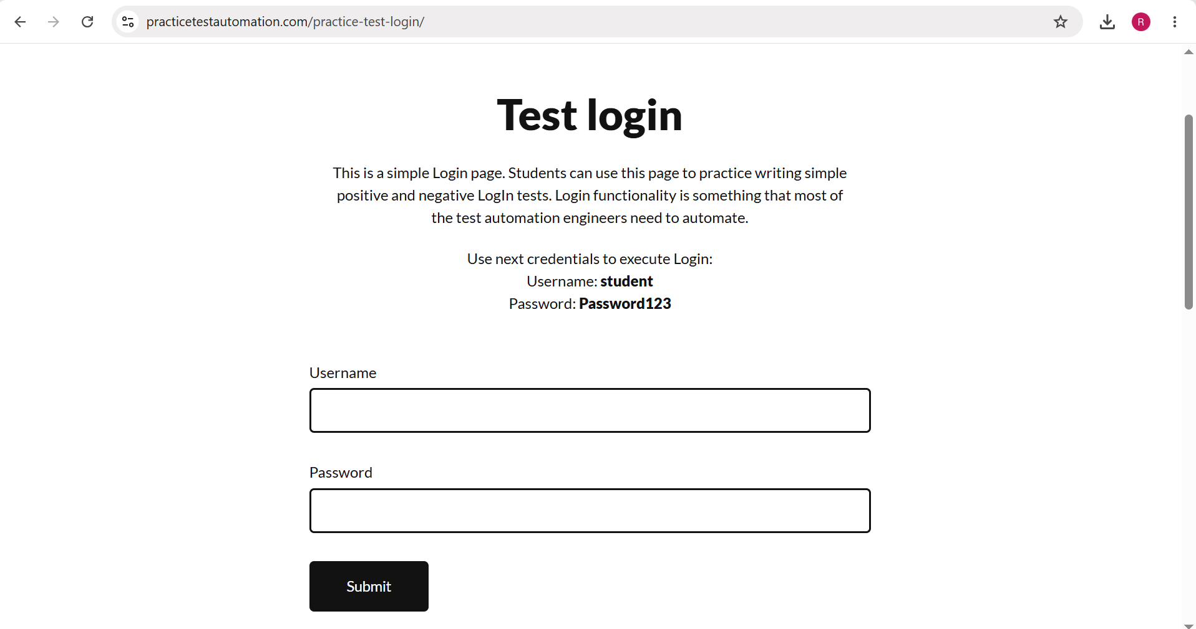

- Scenario ID: 1b
Scenario
Verify Username and Password fields are available
Test Steps
1. Open the login page.
2. Click the Username field.
3. Enter the username student.
4. Click the Password field.
5. Observe both input fields.

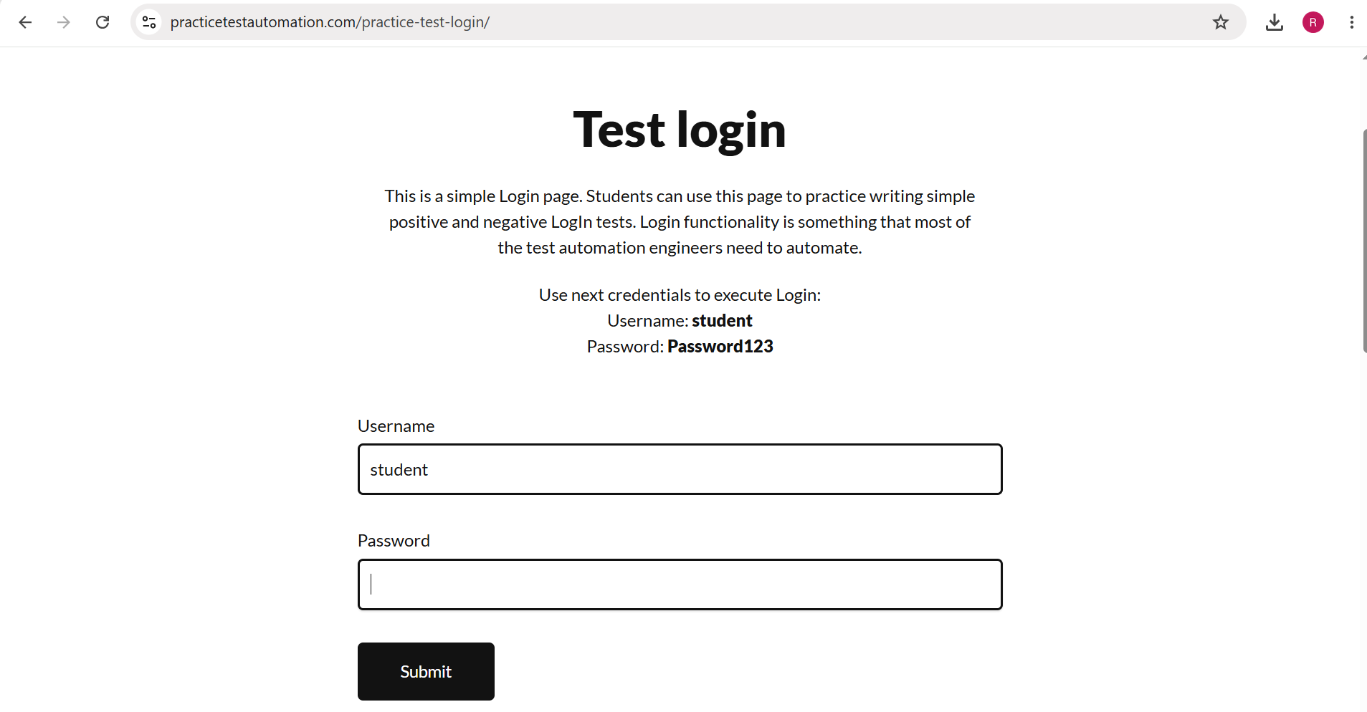

- Scenario ID: 1c
Scenario
Verify Password field masks entered password
Test Steps
1. Open the login page.
2. Enter student in the Username field.
3. Enter Password123 in the Password field.
4. Observe the displayed password characters.
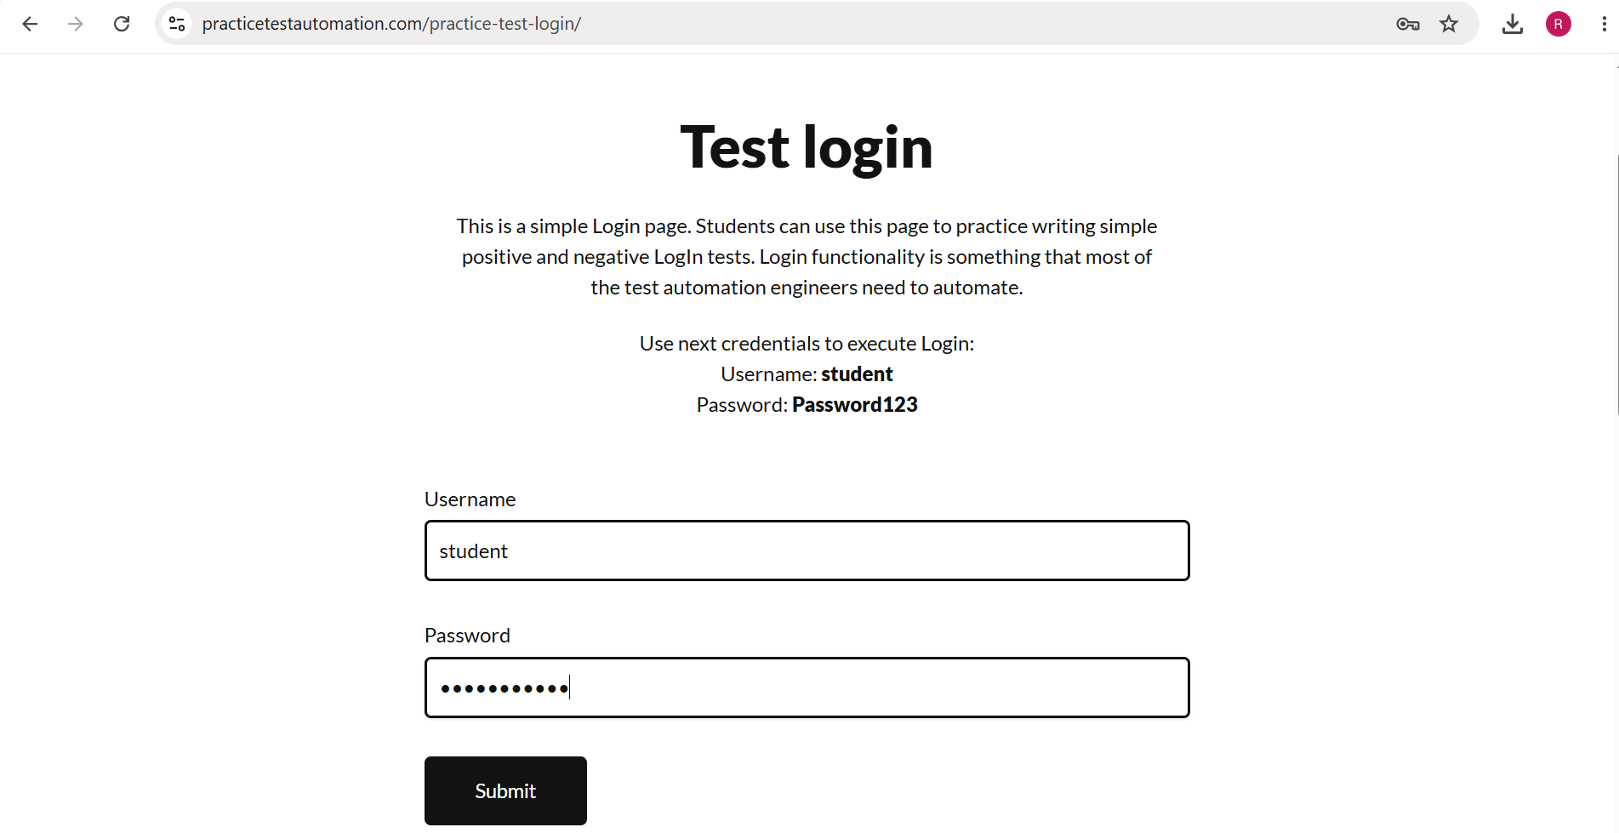

- Scenario ID: 1d
Scenario
Verify login with valid credentials
Test Steps
1. Open the login page.
2. Enter student as Username.
3. Enter Password123 as Password.
4. Click the Submit button.
5. Observe the result.
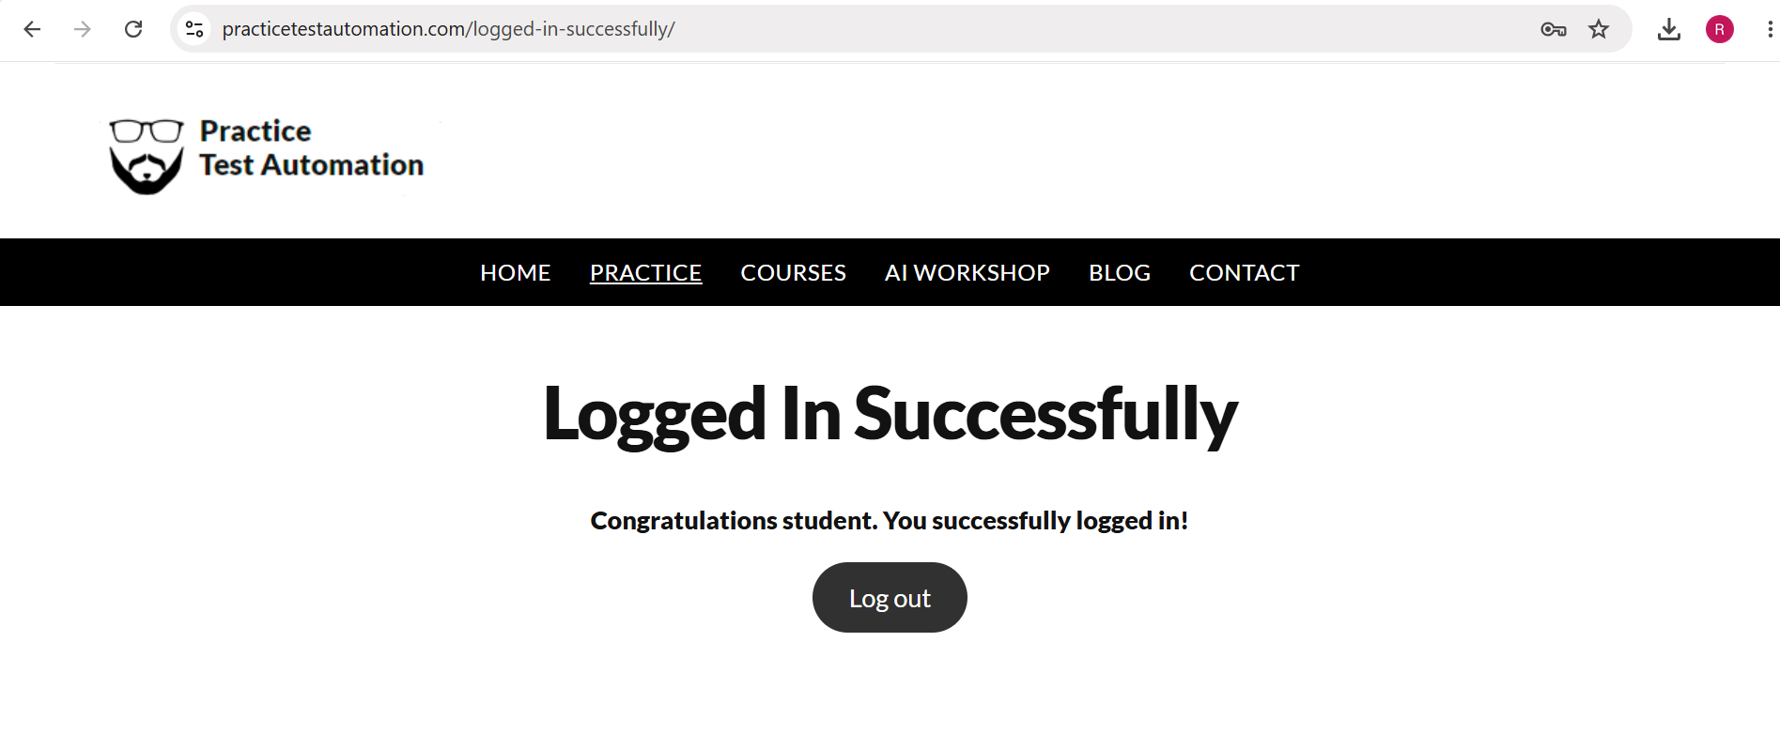

- Scenario ID: 1e
Scenario
Verify login with invalid password
Test Steps
1. Open the login page.
2. Enter student as Username.
3. Enter incorrectPassword as Password.
4. Click the Submit button.
5. Observe the error message.
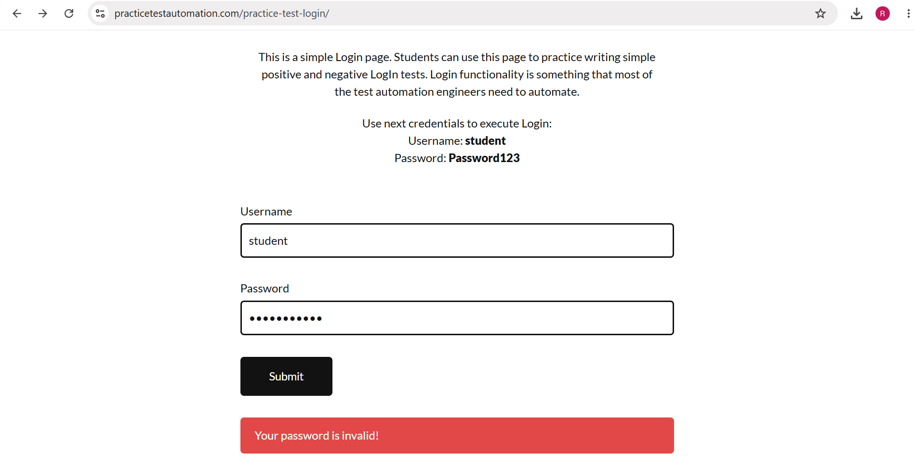

- Scenario ID: 1f
Scenario
Verify Logout functionality
Test Steps
1. Login using valid credentials.
2. Verify that the successful login page is displayed.
3. Click the Log out button.
4. Observe the resulting page.
SDLC & STLC Testing Activity Flow
Requirement Analysis → System Design → Development → Testing → Deployment → Maintenance

Requirement Analysis → Test Planning → Test Case Development → Test Environment Setup → Test Execution → Test Cycle Closure

SDLC Phase | STLC Phase | Testing Activity | Deliverable / Artifact
Requirement Analysis | Requirement Analysis | Identify testable requirements | Requirement Analysis / RTM
System Design | Test Planning | Define testing scope and strategy | Test Plan
Development | Test Case Development | Prepare test scenarios, test cases and test data | Test Cases
Testing Preparation | Test Environment Setup | Prepare browser, website and test environment | Test Environment
Testing | Test Execution | Execute test cases and compare results | Test Execution Results
Maintenance / Closure | Test Cycle Closure | Review results and prepare summary | Test Summary Report

Test Result Summary

Total Test Case | Pass | Fail
6 | 6 | 0

